OXFORD COUNTY COUNCIL
Support and information for your communities
This update contains information and resources that you may find useful to share with your networks, communities and colleagues. These can all be accessed directly via our portal.
How to use this update
✅ Use the information in your newsletters, social media channels or community updates
✅ Adapt the messages and graphics to suit your needs - and share within your networks
✅ To make it as easy as possible, we've created downloadable comms toolkits for our larger campaigns
If you have any questions, please email communications@oxfordshire.gov.uk.

Follow Oxfordshire County Council on WhatsApp
Stay connected with the latest news, updates and alerts from across Oxfordshire.
📢 OCC WhatsApp news channel
Get council news, service updates and local alerts delivered straight to your phone.
🚗 OCC WhatsApp travel channel
Stay ahead of road closures, traffic disruptions and travel alerts across the county.
Alternatively, why not follow us on BlueSky? @oxfordshirecc.bsky.social

Highways information

There is lots happening to raise awareness of the work of the highways team.
- Follow our new LinkedIn showcase page for regular updates on highways maintenance.
- Don't forget our place pages. These will continue to evolve but are designed to help residents understand what's going on in their area and how it contributes to the bigger picture for Oxfordshire.
- Take a look at our highways blogs and share links where you feel it might be useful.
For pre-prepared wording, explainer videos and graphics to help you share information with your communities, visit our highways communication portal.
Grass cutting - this will be coming to an end at the end of September. Visit the grass cutting page on our website. To access wording to use in your own newsletters, visit the grass cutting portal,
Gully cleaning - to see where we'll be this month, visit the cleaning drains and gullies section on our website. To access wording to use in your own newsletters or to download an explainer video, visit the gully cleaning portal.
Potholes - Please continue to report any issues you see: https://fixmystreet.oxfordshire.gov.uk. To access wording to use in your own newsletters or to download explainer videos and graphics, visit the potholes portal.

LGR update for Oxfordshire and West Berkshire

The government has announced it will review its local government reorganisation (LGR) minded to decisions across England to ensure LGR is robust and aligns with its new priorities.
This has implications about the future of councils in Oxfordshire and West Berkshire following its decision in July to create three new unitary authorities for the area.
The scope of the review has not yet been agreed but government wants it to be quick, in the next couple of months. As a result, the timeline for Oxfordshire and West Berkshire will likely be moved back a year. This is yet to be confirmed.
The government has restated its commitment to devolution – the transfer of powers and funding from national to local government – and has said LGR is a fundamental part of achieving this. As a result, preparatory work across Oxfordshire and West Berkshire will continue while the review takes place.
Although timelines may change, councils remain focused on partnership work to prepare for all outcomes and delivering the best services for local communities.
We will keep you informed about the government’s review and what it means for LGR in Oxfordshire and West Berkshire.
Visit our LGR and devolution webpages for the latest news and updates

Traffic filters are replacing the congestion charge

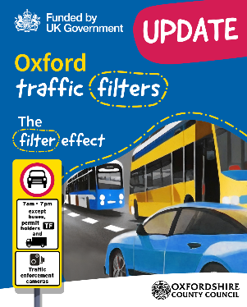
From Monday 28 September the traffic filters trial will replace the congestion charge, and car drivers will no longer have the option to pay the £5 congestion charge. Congestion charge permits will automatically transfer to traffic filters permit. People will not need to reapply.
We’d really appreciate your help in raising awareness about the upcoming change. To make this as easy as possible, we’ve included a set of ready-to-use resources for you to download.

Want to know more about Oxford’s traffic filters?

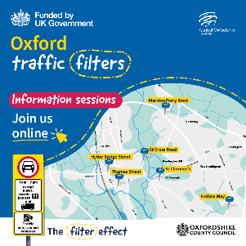
Join us for our next online information sessions to hear how the trial will work, learn about available permits and ask questions.
📅 Monday 14 September
🕕 6pm to 7pm
You do not need to sign up to attend, but you can register to get a reminder and send questions in advance.

The Oxfordshire Flood Toolkit

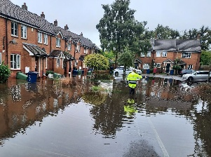
The Oxfordshire Flood Toolkit contains practical advice for homeowners, businesses and communities, including flood prevention tips and guidance on what to do before, during and after flooding.
Taking a few simple steps now could help you stay one step ahead.

NHS Health Checks: Help us spread the word


We want to encourage everyone who's eligible for a free NHS Health Check to take advantage of this opportunity when invited. It’s a great way for people aged 40-74 without a preexisting medical condition to stay on top of their health and wellbeing.
Please could you share this campaign with your audiences to encourage people to book their check when invited.
Our NHS Health Checks communications toolkit contains suggested text for use in newsletters, website or on your own social media channels.

Free electric blanket testing

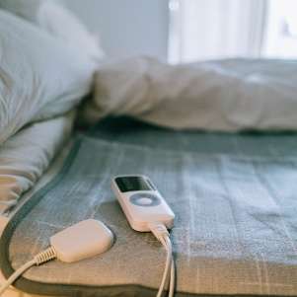
Free electric blanket safety tests are returning from September at locations across the county.
Please encourage your networks to book a test. Find out more about free electric blanket testing.

Air quality tool


Air quality in Oxfordshire varies from place to place - even between streets in the same town. Our free tool shows you an estimate of your personal exposure to air pollution based on where you live and your daily activities. It also tells you what this means for your health, and what you can do about it.
Check the air at your postcode

StreetLink: Local support for rough sleepers

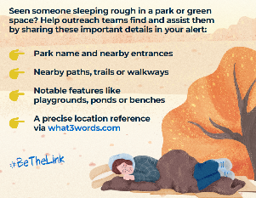
StreetLink is a service that helps residents report people sleeping rough and connects them to local support teams and charities. It would be great if you could help share details of this important service.
Posters can be found here.

Reverse Recruitment Fair - we need you!


We're looking for employers to join Oxfordshire's first Reverse Recruitment Fair on 26 November 2026 at the Kassam Stadium - helping young people with SEND connect with future opportunities.
Meet local talent, strengthen your inclusive recruitment practices and make a real difference to young people's futures.
Interested? Register your interest, or contact lydia.martin@oxfordshire.gov.uk by 30 September.

Connect to Work: Support to find work


Could someone you know benefit from extra support to find work?
If you know someone whose health condition, disability, caring responsibilities or other life challenges are making employment feel out of reach, Connect to Work could help.
The programme offers free, personalised one-to-one support tailored to their individual circumstances. Participants can build confidence, overcome barriers and take steps towards employment at a pace that works for them.

Living well at home

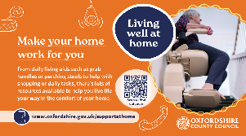
Having a comfortable home really matters, especially as we get older. As we start to need a bit of extra help, it can be hard to know where to begin.
From working out what support is available to understanding the cost of care, there’s a lot to think about. That’s where our living well at home guides come in. They’re designed to make things clearer and help people find the right support at the right time.
Download more information to help spread the word

You might also be interested in...

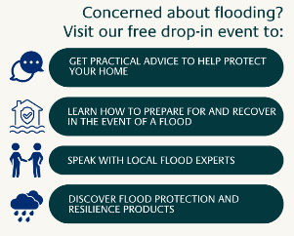
Oxfordshire flood preparation event
Residents and local businesses are invited to attend the Oxfordshire flood preparation event on Thursday 24 September 2026, between 2pm and 7pm at Exeter Hall, Kidlington.

