Support and information for your communities
This update contains information and resources that you may find useful to share with your networks, communities and colleagues. These can all be accessed directly via our portal.
How to use this update
✅ Use the information in your newsletters, social media channels or community updates
✅ Adapt the messages and graphics to suit your needs - and share within your networks
✅ To make it as easy as possible, we've created downloadable comms toolkits for our larger campaigns
If you have any questions, please email communications@oxfordshire.gov.uk.

Follow Oxfordshire County Council on WhatsApp
Stay connected with the latest news, updates and alerts from across Oxfordshire.
📢 OCC WhatsApp news channel
Get council news, service updates and local alerts delivered straight to your phone.
🚗 OCC WhatsApp travel channel
Stay ahead of road closures, traffic disruptions and travel alerts across the county.
Alternatively, why not follow us on BlueSky? @oxfordshirecc.bsky.social

Highways summer snapshot (July to September)

Here’s a summer snapshot of some of the work our highways teams carried out to keep Oxfordshire moving, as we head into autumn.
🕳️ 18,217 potholes repaired
🌧️ 24,207 highway drainage gullies cleansed
🌿 626 sites cleared of grass and vegetation
🛣️ 68,124 sqm of carriageway resurfaced across 36 roads, including a landmark low-carbon resurfacing programme in Chinnor
✅ 48 roads treated with preventative micro surfacing since September
💧 74,549 sqm of road surface sealed and protected to help prevent water ingress and reduce future pothole formation
🏗️ 12 drainage improvement projects completed as part of ongoing flood mitigation work
🔩 118 ironwork repairs completed in the first month of a new programme repairing damaged drain lids and covers
🌉 4 bridge repair projects completed over the summer at Claydon Hay, Clifton Hampden, Sutton Courtenay and Clacks Bridge between Northmoor and Standlake
🚧 4 bridge repair projects currently underway at Burford Bridge (Abingdon), Islip Bridge, Great Rollright Bridge, and the Isis and Weirs Mill Stream bridges
Keeping Oxfordshire moving
Alongside routine maintenance, teams have continued investing in preventative repairs and drainage improvements to help tackle flooding, extend the life of roads and improve journeys across the county.

Highways information

There is lots happening to raise awareness of the work of the highways team.
- Follow our new LinkedIn showcase page for regular updates on highways maintenance.
- Don't forget our place pages. These will continue to evolve but are designed to help residents understand what's going on in their area and how it contributes to the bigger picture for Oxfordshire.
- Take a look at our highways blogs and share links where you feel it might be useful.
For pre-prepared wording, explainer videos and graphics to help you share information with your communities, visit our highways communication portal.
Gully cleaning - To see where we'll be this month, visit the cleaning drains and gullies section on our website. To access wording to use in your own newsletters or to download an explainer video, visit the gully cleaning portal.
Potholes - Please continue to report any issues you see: https://fixmystreet.oxfordshire.gov.uk. To access wording to use in your own newsletters or to download explainer videos and graphics, visit the potholes portal.
Resurfacing - Since May, we've been carrying out a programme of resurfacing on 38 roads covering approximately 115,000 square metres of carriageway. This programme is on track to end in November, with the remaining planned works listed on our website.

Getting Oxfordshire’s roads winter-ready starts long before winter

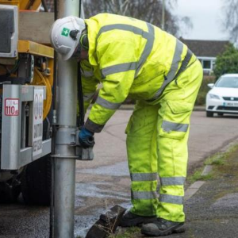
Preparing our roads for winter isn’t just about gritters. Throughout the warmer months, our highways teams have been working to strengthen the road network and help prevent problems before colder, wetter weather arrives.
From surface dressing and resurfacing to drainage improvements and preventative repairs, significant work and investment has gone into preparing Oxfordshire’s roads for the months ahead.
Find out from Councillor Liz Leffman how we’ve been preparing Oxfordshire’s roads for winter

Build a healthier, happier workplace – for free!


Ready to boost wellbeing in your workplace?
Oxfordshire organisations with three or more employees can now sign up for a completely free workplace wellbeing programme.
Participants get:
✅ Free manager training
✅ Practical wellbeing resources and guidance
✅ Specialist support
✅ Anonymous employee survey and tailored insights
✅ A workplace wellbeing certification pathway
Find out more at Thrive at Work Oxfordshire. Please share this opportunity within your networks.

Best Start Family Hubs


Best Start Family Hubs are welcoming places where families can get advice, support and practical help – all in one place.
In Oxfordshire, Best Start Family Hubs are a key part of our approach to supporting families earlier and more effectively. They bring services together around the needs of the whole family are open to all families, from pregnancy through to early years and beyond.
We'd really appreciate your help in promoting Best Start Family Hubs and the support they offer, to families in Oxfordshire.
To make this as easy as possible, we’ve created a communications toolkit for you to use with messages and graphics.

Help us keep the word going about traffic filters


Almost a month into Oxford’s traffic filters, we’d still really appreciate your help sharing information through your networks, particularly with people who may not use social media.
Permits are available for many groups, including Oxfordshire residents, Blue Badge holders, community health and care workers, and mobile traders.
Please keep sharing our ready-to-use resources to help people understand the changes and their travel choices.

Free, local support to stop smoking


There’s still time to take part in Stoptober and take a positive step towards becoming smoke-free.
And support doesn’t stop at the end of October. Whenever you’re ready to quit, Smoke Free Oxon offers free local support, advice and quit-smoking aids to help you find an approach that works for you.
Please help us spread the word and encourage others to find out more about Smoke Free Oxon

The Oxfordshire Flood Toolkit

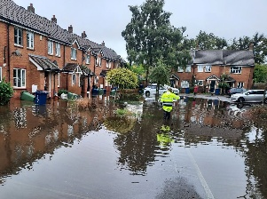
With wetter and stormier weather forecast, now’s the time to prepare for flooding. The Oxfordshire Flood Toolkit contains practical advice for homeowners, businesses and communities, including flood prevention tips and guidance on what to do before, during and after flooding.

Private fostering


Could you help spread the word about private fostering?
Private fostering is when a child is looked after by someone who isn’t their parent or a close relative for 28 days or more, without a formal arrangement with the council or a fostering agency.
Many people don’t realise this is private fostering or that the council must be notified by law.
You can help by:
- Sharing information with your networks
- Helping families recognise private fostering arrangements
- Encouraging people to notify the council so the right support can be put in place
Download our communications toolkit to help spread the word

NHS Health Checks: Help us spread the word


We want to encourage everyone who's eligible for a free NHS Health Check to take advantage of this opportunity when invited. It’s a great way for people aged 40-74 without a preexisting medical condition to stay on top of their health and wellbeing.
Please could you share this campaign with your audiences to encourage people to book their check when invited.
Our NHS Health Checks communications toolkit contains suggested text for use in newsletters, website or on your own social media channels.

StreetLink: Local support for rough sleepers

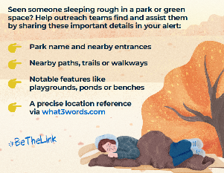
StreetLink is a service that helps residents report people sleeping rough and connects them to local support teams and charities. It would be great if you could help share details of this important service.

